**Attrition Assignment Solution**

**Step1 - Launching**

import pandas as pd

import matplotlib.pyplot as plt

dbDataset = pd.read_csv(‘general_data.csv’)

dbDataset.head()

Out[1]:

Age Attrition ... YearsSinceLastPromotion YearsWithCurrManager

0 51 No ... 0 0

1 31 Yes ... 1 4

2 32 No ... 0 3

3 38 No ... 7 5

4 32 No ... 0 4

[5 rows x 24 columns]

dbDataset.columns

Out[2]:

Index(['Age', 'Attrition', 'BusinessTravel', 'Department', 'DistanceFromHome',

'Education', 'EducationField', 'EmployeeCount', 'EmployeeID', 'Gender',

'JobLevel', 'JobRole', 'MaritalStatus', 'MonthlyIncome',

'NumCompaniesWorked', 'Over18', 'PercentSalaryHike', 'StandardHours',

'StockOptionLevel', 'TotalWorkingYears', 'TrainingTimesLastYear',

'YearsAtCompany', 'YearsSinceLastPromotion', 'YearsWithCurrManager'],

dtype='object')

**Step 2 - Data Treatment:**

dbDataset.isnull()

Out[3]:

Age Attrition ... YearsSinceLastPromotion YearsWithCurrManager

0 False False ... False False

1 False False ... False False

2 False False ... False False

3 False False ... False False

4 False False ... False False

... ... ... ... ...

4405 False False ... False False

4406 False False ... False False

4407 False False ... False False

4408 False False ... False False

4409 False False ... False False

[4410 rows x 24 columns]

dbDataset.duplicated()

Out[4]:

0 False

1 False

2 False

3 False

4 False

4405 False

4406 False

4407 False

4408 False

4409 False

Length: 4410, dtype: bool

dbDataset.drop_duplicates()

Out[5]:

Age Attrition ... YearsSinceLastPromotion YearsWithCurrManager

0 51 No ... 0 0

1 31 Yes ... 1 4

2 32 No ... 0 3

3 38 No ... 7 5

4 32 No ... 0 4

... ... ... ... ...

4405 42 No ... 0 2

4406 29 No ... 0 2

4407 25 No ... 1 2

4408 42 No ... 7 8

4409 40 No ... 3 9

[4410 rows x 24 columns]

**Step 3 – Univariate Analysis:**

dbSecondDataset = dbDataset[['Age','DistanceFromHome','Education','MonthlyIncome', 'NumCompaniesWorked', 'PercentSalaryHike','TotalWorkingYears', 'TrainingTimesLastYear', 'YearsAtCompany','YearsSinceLastPromotion', 'YearsWithCurrManager']].describe()

dbSecondDataset

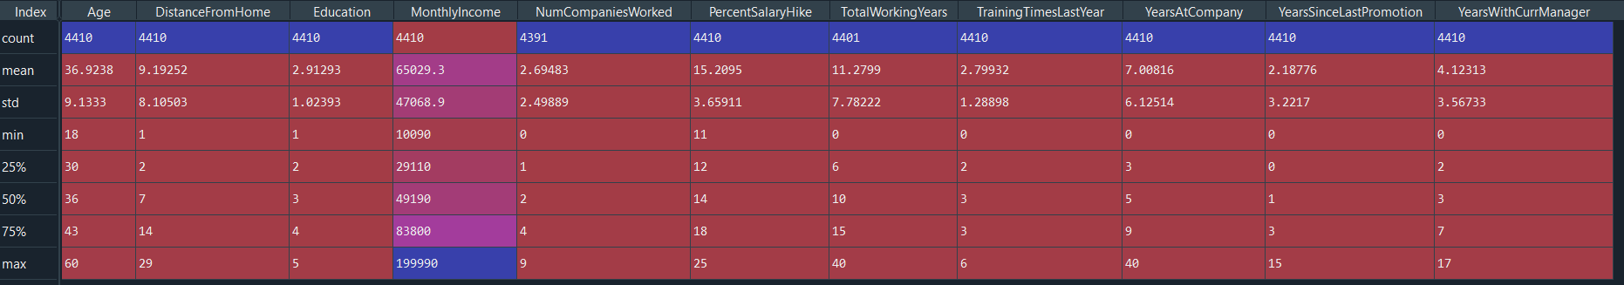

dbSecondDataset = dbDataset [['Age','DistanceFromHome','Education','MonthlyIncome', 'NumCompaniesWorked', 'PercentSalaryHike','TotalWorkingYears', 'TrainingTimesLastYear', 'YearsAtCompany','YearsSinceLastPromotion', 'YearsWithCurrManager']].median()

dbSecondDataset

Out[7]:

Age 36.0

DistanceFromHome 7.0

Education 3.0

MonthlyIncome 49190.0

NumCompaniesWorked 2.0

PercentSalaryHike 14.0

TotalWorkingYears 10.0

TrainingTimesLastYear 3.0

YearsAtCompany 5.0

YearsSinceLastPromotion 1.0

YearsWithCurrManager 3.0

dtype: float64

dbSecondDataset = dbDataset[['Age','DistanceFromHome','Education','MonthlyIncome', 'NumCompaniesWorked', 'PercentSalaryHike','TotalWorkingYears', 'TrainingTimesLastYear', 'YearsAtCompany','YearsSinceLastPromotion', 'YearsWithCurrManager']].mode()

dbSecondDataset

Out[8]:



dbSecondDataset = dbDataset [['Age','DistanceFromHome','Education','MonthlyIncome', 'NumCompaniesWorked', 'PercentSalaryHike','TotalWorkingYears', 'TrainingTimesLastYear', 'YearsAtCompany','YearsSinceLastPromotion', 'YearsWithCurrManager']].var()

dbSecondDataset

Out[9]:

Age 8.341719e+01

DistanceFromHome 6.569144e+01

Education 1.048438e+00

MonthlyIncome 2.215480e+09

NumCompaniesWorked 6.244436e+00

PercentSalaryHike 1.338907e+01

TotalWorkingYears 6.056298e+01

TrainingTimesLastYear 1.661465e+00

YearsAtCompany 3.751728e+01

YearsSinceLastPromotion 1.037935e+01

YearsWithCurrManager 1.272582e+01

dtype: float64

dbSecondDataset = dbDataset[['Age','DistanceFromHome','Education','MonthlyIncome', 'NumCompaniesWorked', 'PercentSalaryHike','TotalWorkingYears', 'TrainingTimesLastYear', 'YearsAtCompany','YearsSinceLastPromotion', 'YearsWithCurrManager']].skew()

dbSecondDataset

Out[9]:

Age 0.413005

DistanceFromHome 0.957466

Education -0.289484

MonthlyIncome 1.368884

NumCompaniesWorked 1.026767

PercentSalaryHike 0.820569

TotalWorkingYears 1.116832

TrainingTimesLastYear 0.552748

YearsAtCompany 1.763328

YearsSinceLastPromotion 1.982939

YearsWithCurrManager 0.832884

dtype: float64

dbSecondDataset = dbDataset[['Age','DistanceFromHome','Education','MonthlyIncome', 'NumCompaniesWorked', 'PercentSalaryHike','TotalWorkingYears', 'TrainingTimesLastYear', 'YearsAtCompany','YearsSinceLastPromotion', 'YearsWithCurrManager']].kurt()

dbSecondDataset

Out[10]:

Age -0.405951

DistanceFromHome -0.227045

Education -0.560569

MonthlyIncome 1.000232

NumCompaniesWorked 0.007287

PercentSalaryHike -0.302638

TotalWorkingYears 0.912936

TrainingTimesLastYear 0.491149

YearsAtCompany 3.923864

YearsSinceLastPromotion 3.601761

YearsWithCurrManager 0.167949

dtype: float64

**Inference from the analysis:**

• All the above variables show positive skewness except education; while Age, Distancefromhome, Education & Percentsalaryhike are platykurtic and all other variables are leptokurtic.

• The Mean MonthlyIncome’s IQR is at 54K suggesting company-wide attrition across all income bands

• Mean age forms a near normal distribution with 13 years of IQR

**Outliers:**

There’s no regression found while plotting Age, MonthlyIncome, TotalWorkingYears, YearsAtCompany, etc., on a scatter plot

box_plot = dbDataset.Age

plt.boxplot(box_plot)

Out[11]:

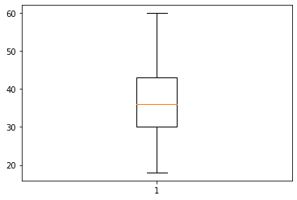Age is normally distributed without any outliers

box_plot = dbDataset.MonthlyIncome

plt.boxplot(box_plot)

Out[12]:

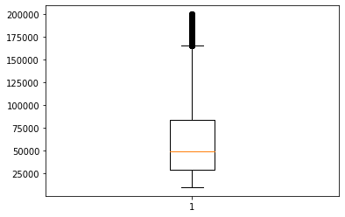Monthly Income is Right skewed with several outliers

box_plot = dbDataset.YearsAtCompany

plt.boxplot(box_plot)

Out[13]:

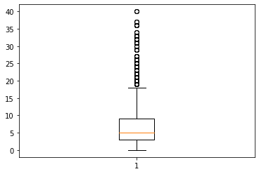Years at company is also Right Skewed with several outliers observed.